BUDGET MANAGEMENT SYSTEM

PROJECT OUTPUT LAYERS

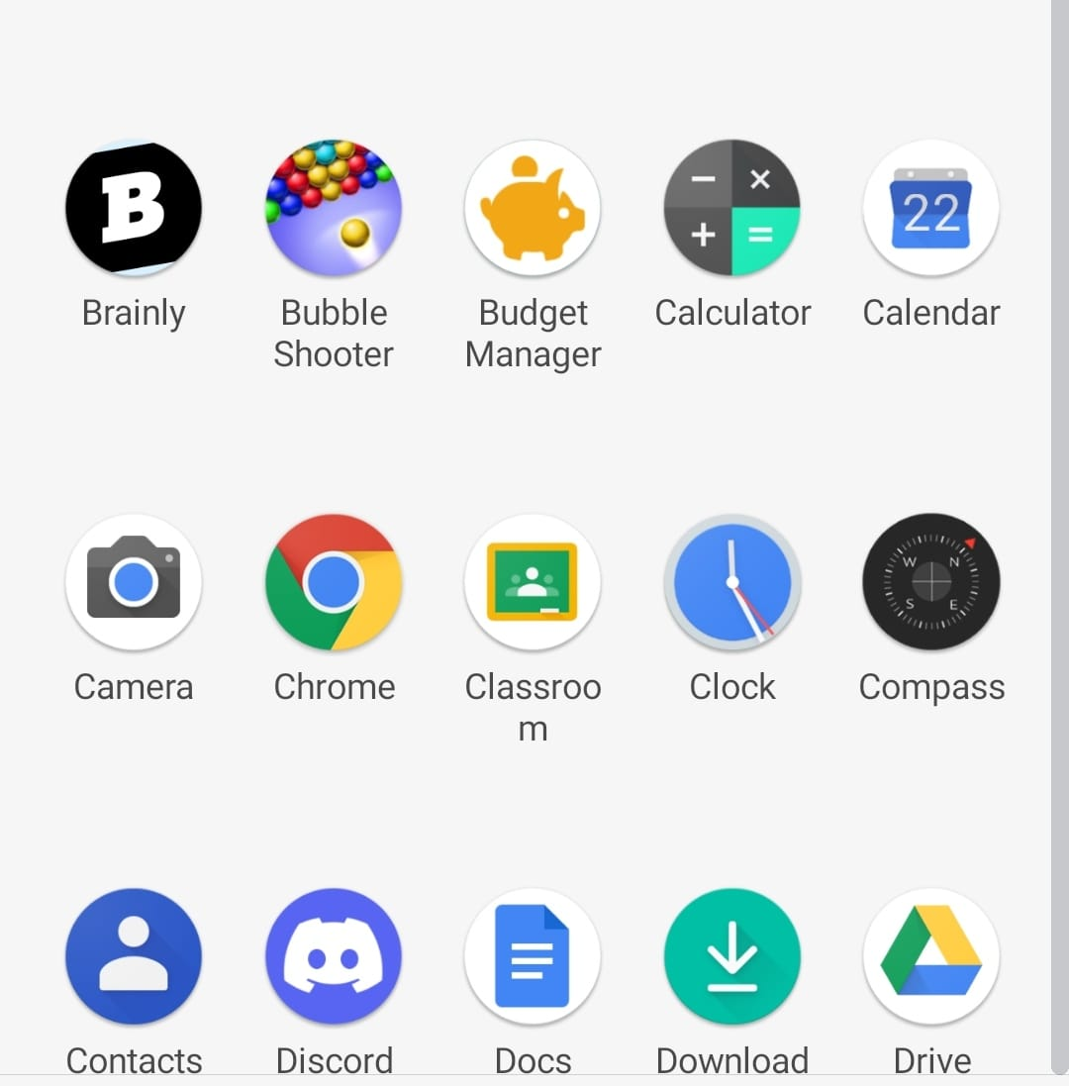

Home page :-

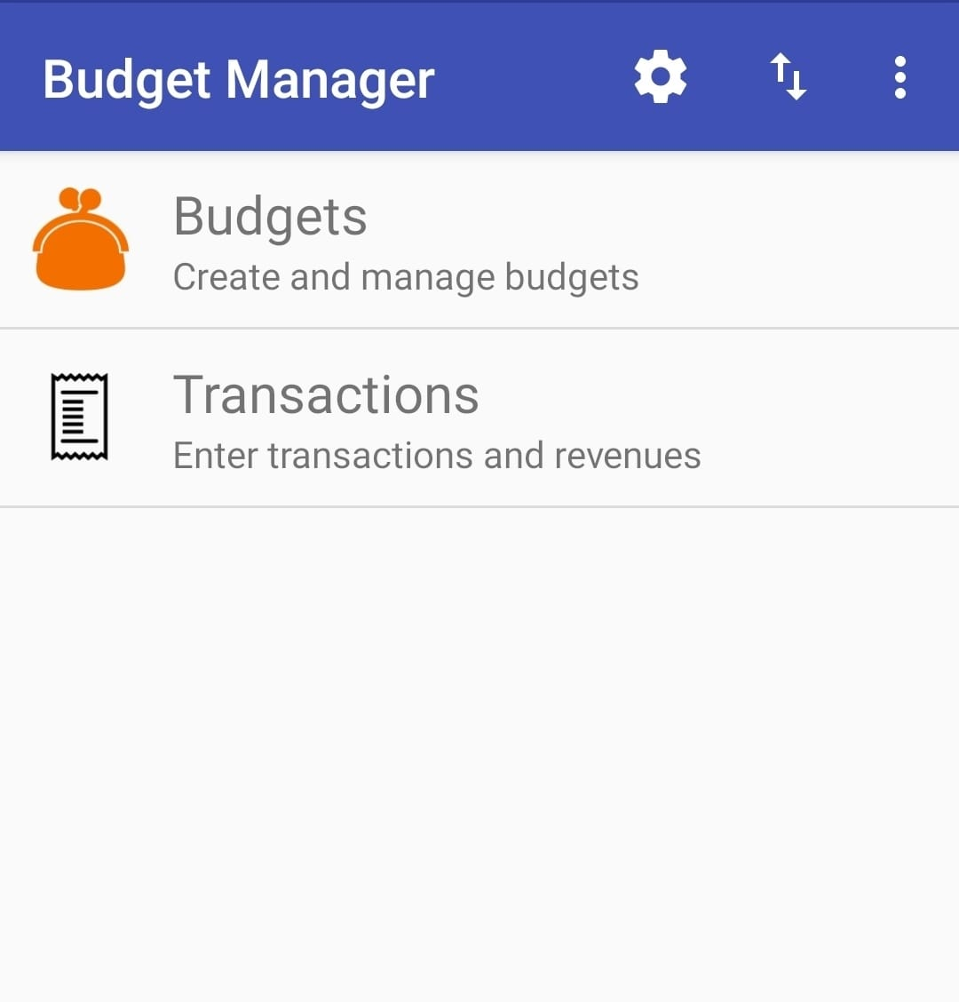

Budget page :-

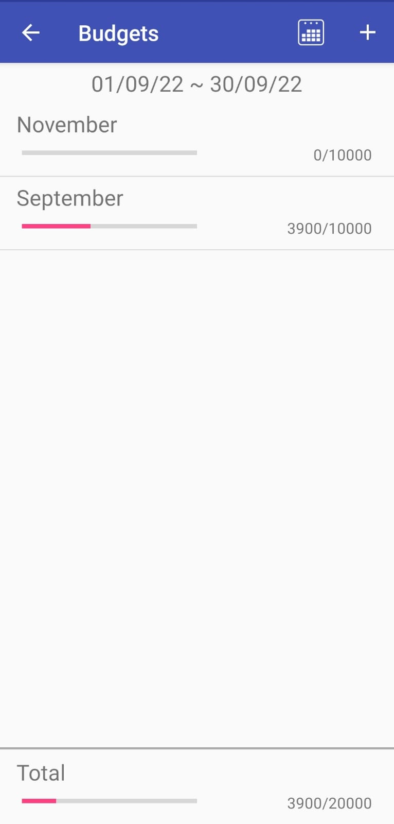

Expenses page



ADD BUDGET PAGE

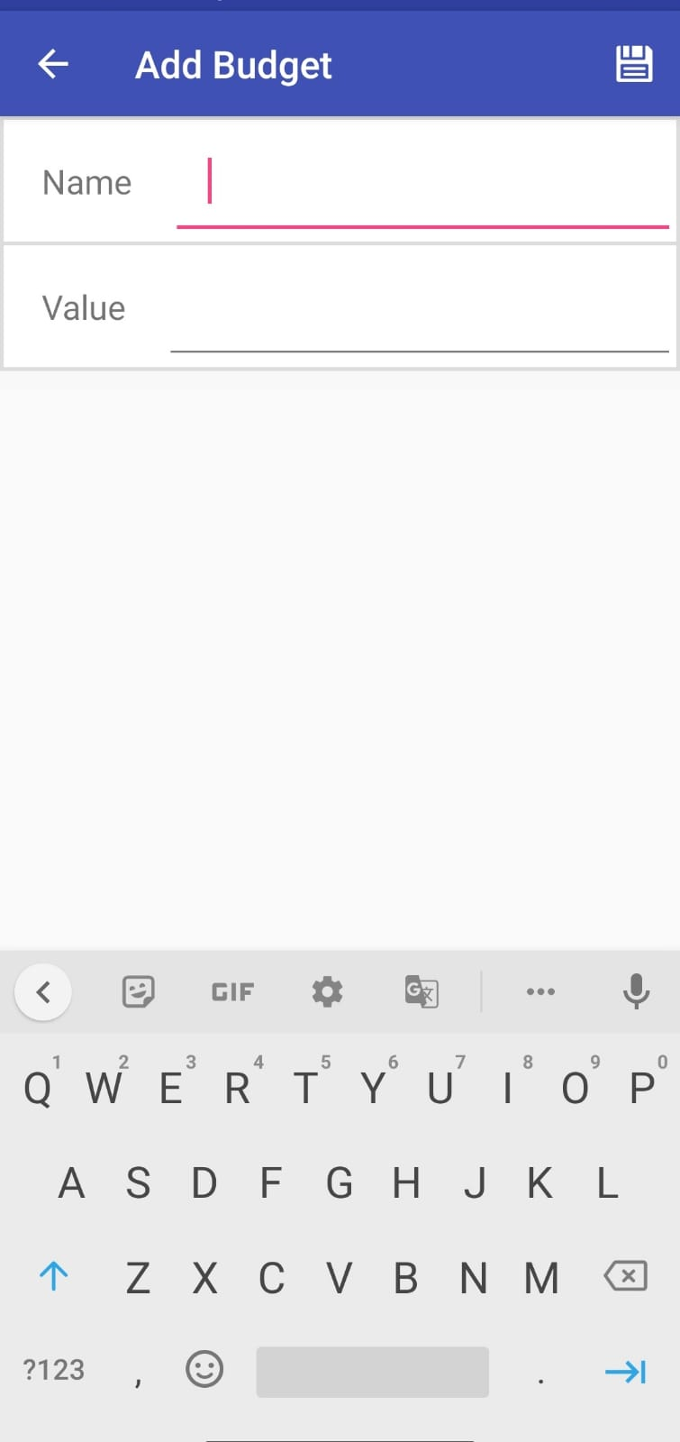

CALENDER PAGE :-

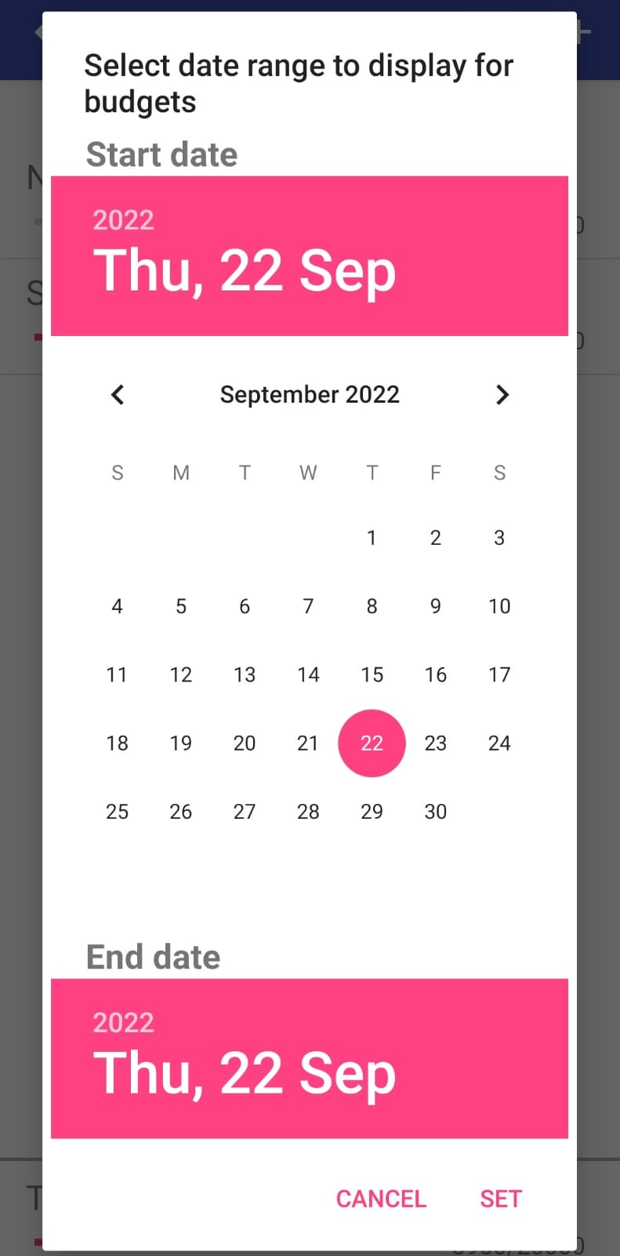

TRANSACTION PAGE :-



REVENUE PAGE :-



